Resolution # 21713

IN THE COUNTY LEGISLATURE OF JACKSON COUNTY, MISSOURI

A RESOLUTION authorizing the County Executive to execute a Cooperative Agreement with the Jackson County Historical Society for record archiving services, at an actual cost to the County in the amount of $36,000.00.

RESOLUTION NO. 21341, July 17, 2023

INTRODUCED BY DaRon McGee, County Legislator

WHEREAS, it is in the best interest of Jackson County to have records with historical value preserved and professionally archived for the scholars and citizens of the County; and,

WHEREAS, the Director of the Recorder of Deeds Department recommends a Cooperative Agreement with the Jackson County Historical Society for professional archiving services for the period of January 1, 2023, through December 31, 2023; and,

WHEREAS, the Jackson County Historical Society has the expertise to provide such professional archiving services; now therefore,

BE IT RESOLVED by the County Legislature of Jackson County, Missouri, that the County Executive be, and hereby is, authorized to execute the attached Cooperative Agreement with the Jackson County Historical Society for professional archiving services, at an actual cost to the County in the amount of $36,000.00; and,

BE IT FURTHER RESOLVED that the Director of Finance and Purchasing is authorized to make all payments, including final payment, on the agreement.
Effective Date: This Resolution shall be effective immediately upon its passage by a majority of the Legislature.
APPROVED AS TO FORM:

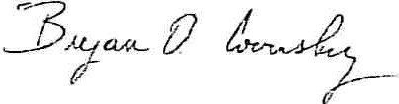
County Counselor

Certificate of Passage

I hereby certify that t attached resolution, Resolution No. 21341 of July 17, 2023, was duly passed on & , 2023 by the Jackson County Legislature. The votes the on w e as follows:

Yeas ----=9------
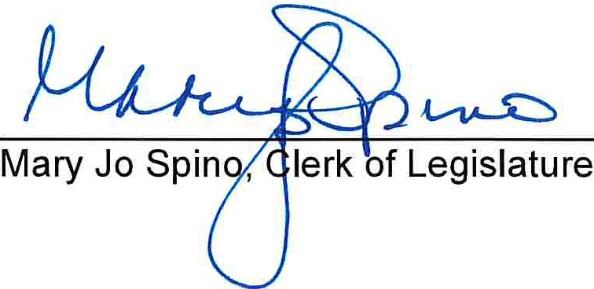
Abstaining Q _
Nays D _

Absent
0

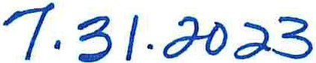

Date

There is a balance otherwise unencumbered to the credit of the appropriation to which the expenditure is chargeable and there is a cash balance otherwise unencumbered in the treasury to the credit of the fund from which payment is to be made each sufficient to provide for the obligation herein authorized.

ACCOUNT NUMBER: ACCOUNT TITLE:

NOT TO EXCEED:
044 1805 56070
Recorder's Fee Fund JC Historical Society
Intergovernmental Agreements
$36,000.00

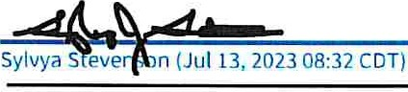
Jul13,2023
Date Chief Administrative Officer

