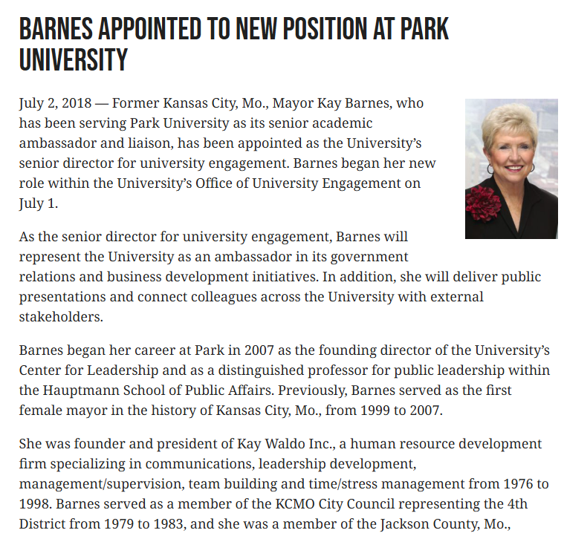
Distinguished Professor for Public Leadership & Founding Director, Center for Leadership, Hauptmann School for Public Affairs, Park University. Former Mayor, Kansas City, Missouri; Chair, Tax Increment Financing Commission, City of Kansas City, Missouri; Representative-at Large, 4th District, City Council of Kansas City, Missouri; President, Kay Waldo, Inc.; Representative-at-Large, 4th District, Jackson County Legislature, Missouri.
