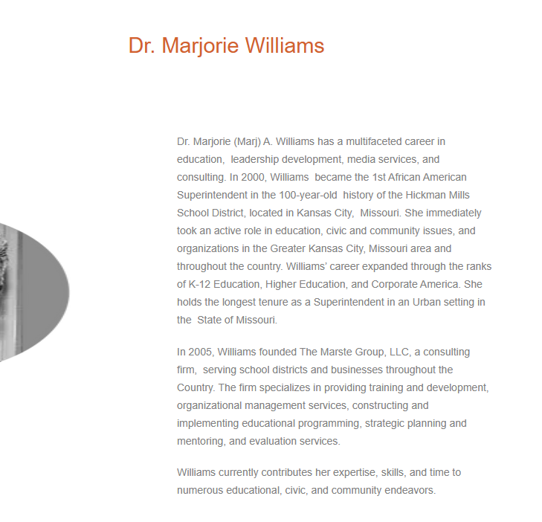
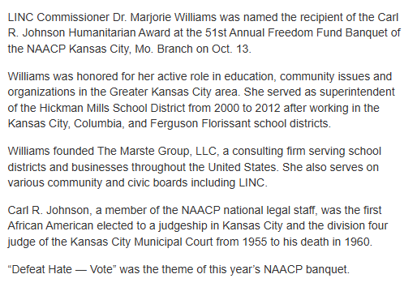
Dr. Marjorie Williams, known widely as Dr. Marj, has given nearly 40 years in service of schools, children, university scholars and teachers. In 2000, she became the first African American superintendent of Hickman Mills School District. Dr. Williams began her career in education with teaching and administrative roles in Kansas City Public Schools and the Columbia and Ferguson-Florissant districts before becoming superintendent. She has also taught as an adjunct professor at UMKC, Baker University, Ottawa University and Kansas State University. In 2012, she founded The Marste Group, a national consulting firm. Additionally, she co-founded the Sisters’ Circle Fund-Greater Kansas City in 2016 and mentors women of color through Societas Docta. Dr. Williams co-chaired the 2021 Starr Women’s Hall of Fame Awards with Alicia Starr.

